Image Preprocessing

|  |  |
| --- | --- |
| Date | 14-11-2022 |
| Team ID | PNT2022TMID13897 |
| Project Name | AI-Powered Nutrition Analyzer For Fitness Enthusiasts |

# Import The Image Data Generator Library

import keras

from keras.preprocessing.image import Image Data Generator

# Configure Image Data Generator Class

train_datagen=ImageDataGenerator(rescale=1./255,shear_range=0.2,zoom_range=0.2,horizontal_flip=T rue)

test_datagen=ImageDataGenerator(rescale=1./255)

# Apply Image DataGenerator Functionality To Trainset And Testset

from google.colab import drive drive.mount('/content/drive')

x_train = train_datagen.flow_from_directory(r'/content/drive/MyDrive/Project/Dataset/TRAIN_SET',target_size=( 64, 64),batch_size=5,color_mode='rgb',class_mode='sparse')

x_test

=test_datagen.flow_from_directory(r'/content/drive/MyDrive/Project/Dataset/TRAIN_SET',target_size= (64, 64),batch_size=5,color_mode='rgb',class_mode='sparse')

print(x_train.class_indices)

print(x_test.class_indices)

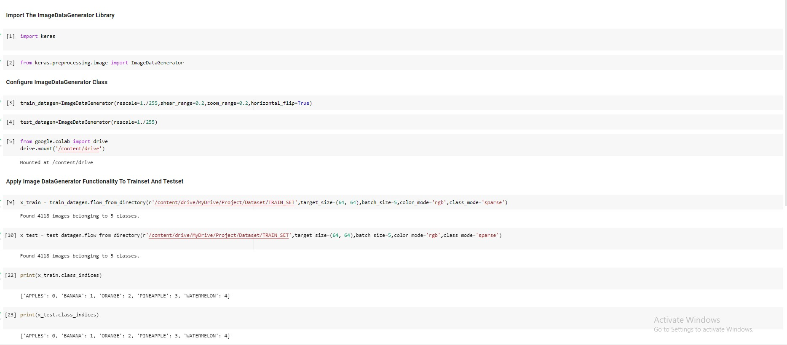

from collections import Counter as c c(x_train .labels)